**Evidence Gathering Document for SQA Level 8 Professional Developer Award.**

This document is designed for you to present your screenshots and diagrams relevant to the PDA and to also give a short description of what you are showing to clarify understanding for the assessor.

|  |  |  |  |
| --- | --- | --- | --- |
| **Unit** | **Ref.** | **Evidence** | **Done** |
| I & T | I.T 5 | Demonstrate the use of an array in a program. Take screenshots of:  *An array in a program  *A function that uses the array  *The result of the function running |  |

Each point that required details the Assessment Criteria (What you have to show) along with a brief description of the kind of things you should be showing.

Please fill in each point with screenshot or diagram and description.

**Week 2**

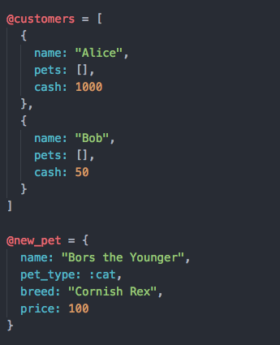

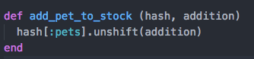

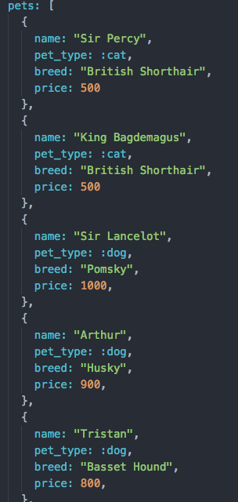

| Unit | Ref | Evidence |  |
| --- | --- | --- | --- |
| I&T | I.T.6 | Demonstrate the use of a hash in a program. Take screenshots of:  *A hash in a program  *A function that uses the hash  *The result of the function running | |

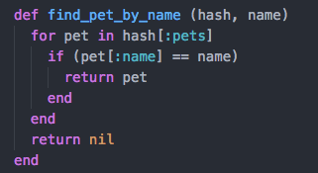



**Week 3**

| Unit | Ref | Evidence |  |
| --- | --- | --- | --- |
| I&T | I.T.3 | Demonstrate searching data in a program. Take screenshots of:  *Function that searches data  *The result of the function running | |

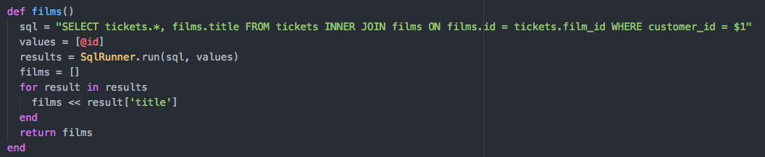

| Unit | Ref | Evidence |  |
| --- | --- | --- | --- |
| I&T | I.T.4 | Demonstrate sorting data in a program. Take screenshots of:  *Function that sorts data  *The result of the function running | |

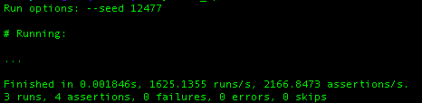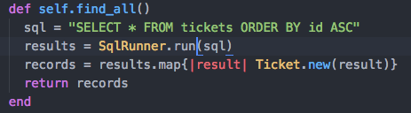

**Week 5**

| Unit | Ref | Evidence |  |
| --- | --- | --- | --- |
| A&D | A.D.1 | A Use Case Diagram | |

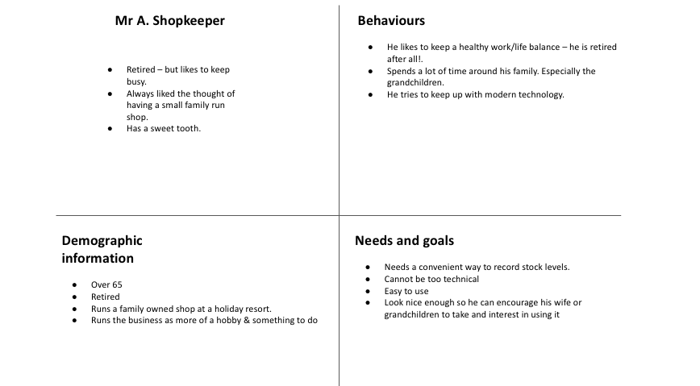

| Unit | Ref | Evidence |  |
| --- | --- | --- | --- |
| A&D | A.D.2 | A Class Diagram | |

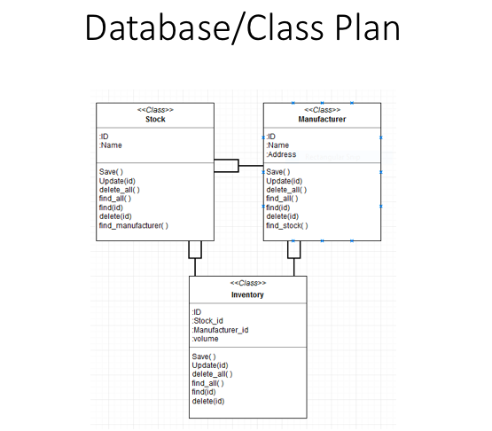

| Unit | Ref | Evidence |  |
| --- | --- | --- | --- |
| A&D | A.D.3 | An Object Diagram | |

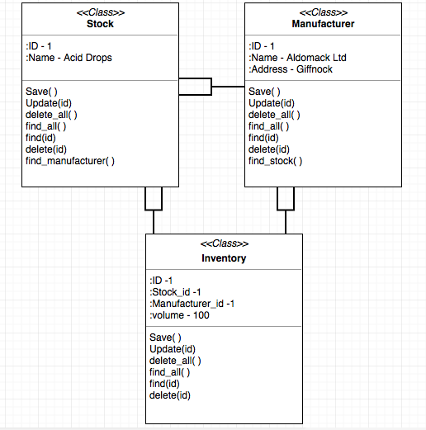

| Unit | Ref | Evidence |  |
| --- | --- | --- | --- |
| A&D | A.D.4 | An Activity Diagram | |

**Paste Screenshot here**

| Unit | Ref | Evidence |  |
| --- | --- | --- | --- |
| A&D | A.D.6 | Produce an Implementations Constraints plan detailing the following factors:  *Hardware and software platforms  *Performance requirements  *Persistent storage and transactions  *Usability  *Budgets  *Time | |

|  |  |  |
| --- | --- | --- |
| **Implementation Constraints Plan** | | |
| **Topic** | **Possible effect of the constraint on Product** | **Solution** |
|
| Hardware and Software Platforms | Using an out of date browser could compromise the users ability to access content | Update browsers to latest version |
|
| Performance Requirements | Slow internet connection could cause timeout errors etc making the application inaccessible | Make the bandwidth required to load the pages to a minimum. Ie no large images etc |
|
| Persistant Strorage | Limited Storage space could mean that should the users business expand there might not be enough space to store data on all stock | Expand storage space or use a third party provider to allow for scaling in future. |
|
| Usability | Application currently has issues displaying on table or mobile device | Make the application available on smaller screen sizes by Improving CSS |
|
| Budgets | Budget might be too small for the project the client currently wants us to undertake | Ask the client to increase the budget or provide cheaper options for basic functionality |
|
| Time Limitations | Short deadline leave little room for unforeseeable issues | Plan extensively and seek help if issues occur as early as possible |
|

| Unit | Ref | Evidence |  |
| --- | --- | --- | --- |
| P | P.5 | User Site Map | |

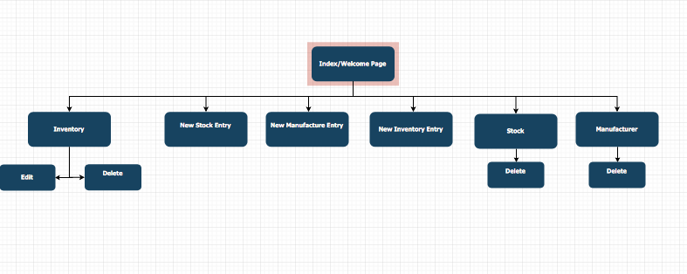

| Unit | Ref | Evidence |  |
| --- | --- | --- | --- |
| P | P.6 | 2 Wireframe Diagrams | |

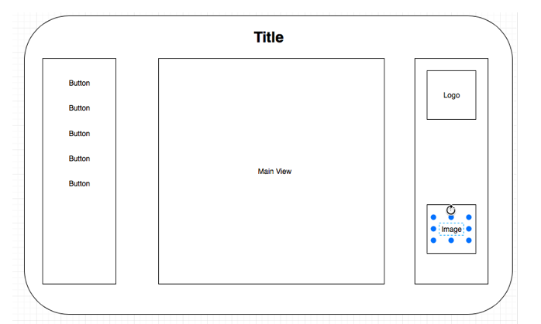

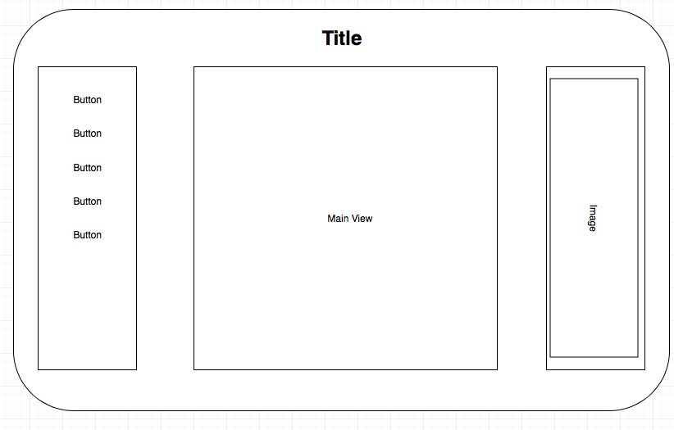

| Unit | Ref | Evidence |  |
| --- | --- | --- | --- |
| P | P.10 | Example of Pseudocode used for a method | |

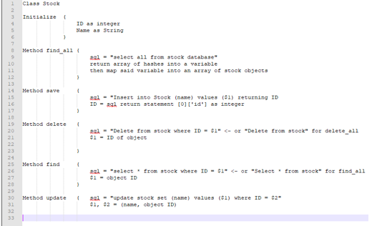

| Unit | Ref | Evidence |  |
| --- | --- | --- | --- |
| P | P.13 | Show user input being processed according to design requirements. Take a screenshot of:  * The user inputting something into your program  * The user input being saved or used in some way | |

**Paste Screenshot**

**Description here**

| Unit | Ref | Evidence |  |
| --- | --- | --- | --- |
| P | P.14 | Show an interaction with data persistence. Take a screenshot of:  * Data being inputted into your program  * Confirmation of the data being saved | |

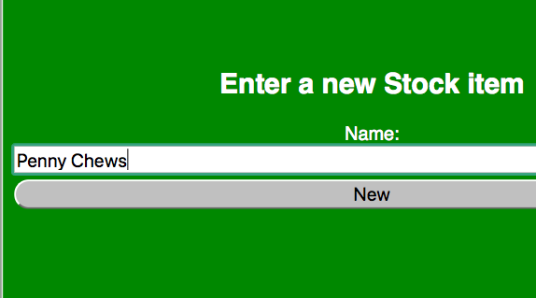

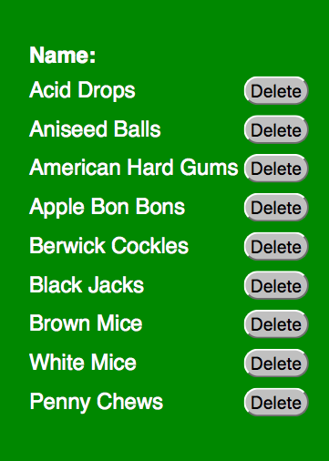

| Unit | Ref | Evidence |  |
| --- | --- | --- | --- |
| P | P.15 | Show the correct output of results and feedback to user. Take a screenshot of:  * The user requesting information or an action to be performed  * The user request being processed correctly and demonstrated in the program | |

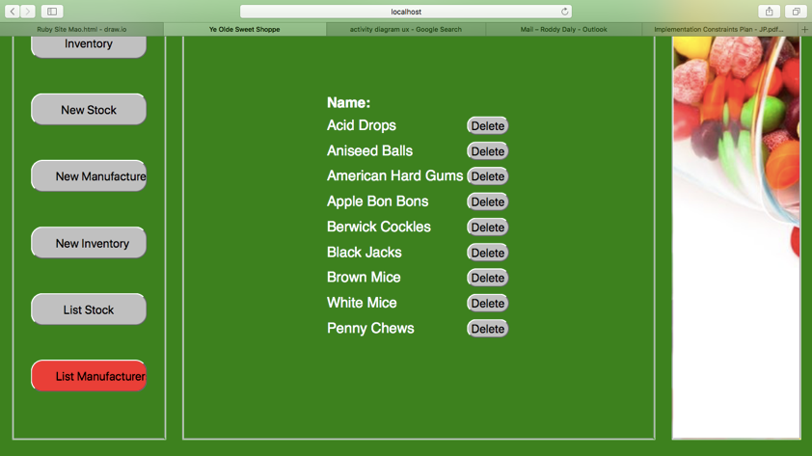

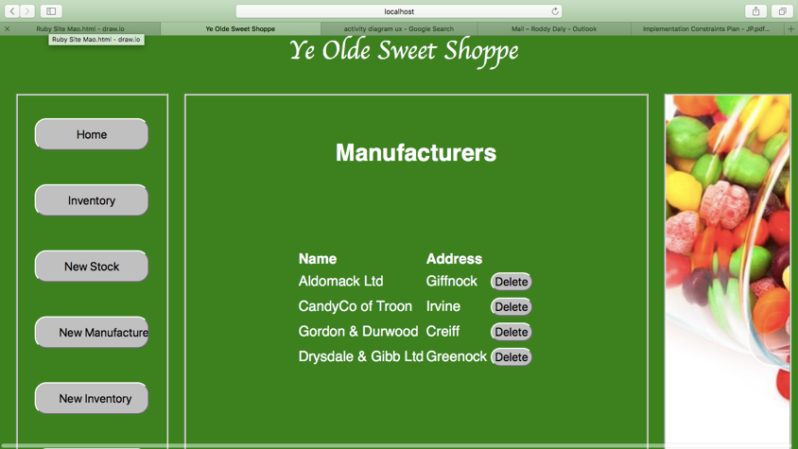

| Unit | Ref | Evidence |  |
| --- | --- | --- | --- |
| P | P.18 | Demonstrate testing in your program. Take screenshots of:  * Example of test code  * The test code failing to pass  * Example of the test code once errors have been corrected  * The test code passing | |

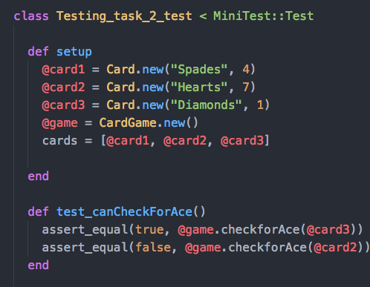

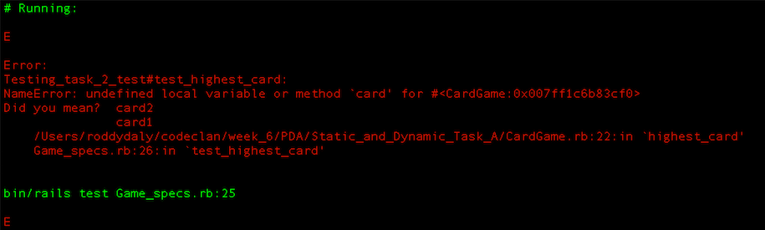



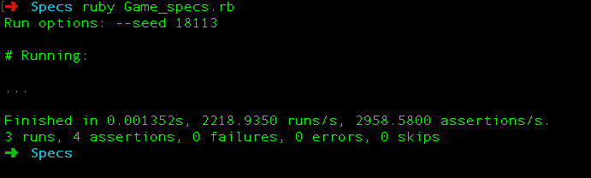

**Week 7**

| Unit | Ref | Evidence |  |
| --- | --- | --- | --- |
| I&T | I.T.7 | The use of Polymorphism in a program and what it is doing. | |

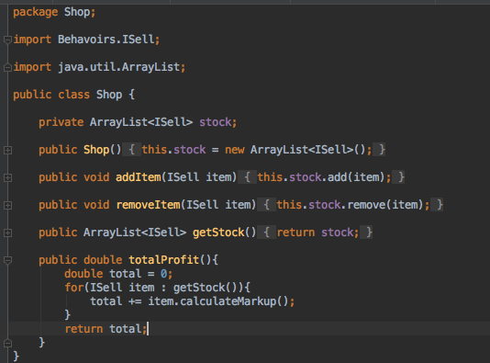



Here all objects implement the ISell interface and as such can be added into and ArrayList of ISell Objects

| Unit | Ref | Evidence |  |
| --- | --- | --- | --- |
| A&D | A.D.5 | An Inheritance Diagram | |

**Paste Screenshot here**

**Description here**

| Unit | Ref | Evidence |  |
| --- | --- | --- | --- |
| I&T | I.T.1 | The use of Encapsulation in a program and what it is doing. | |



**Here the variables used are private and can only be accessed outside the class via the methods**

| Unit | Ref | Evidence |  |
| --- | --- | --- | --- |
| I&T | I.T.2 | Take a screenshot of the use of Inheritance in a program. Take screenshots of:  *A Class  *A Class that inherits from the previous class  *An Object in the inherited class  *A Method that uses the information inherited from another class. | |

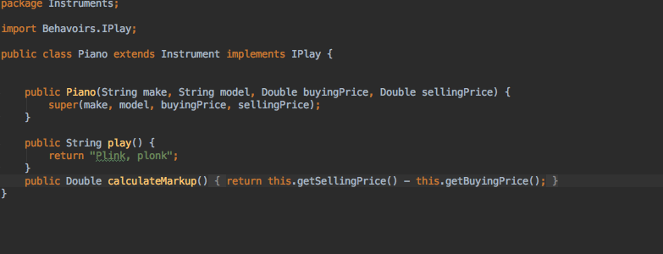

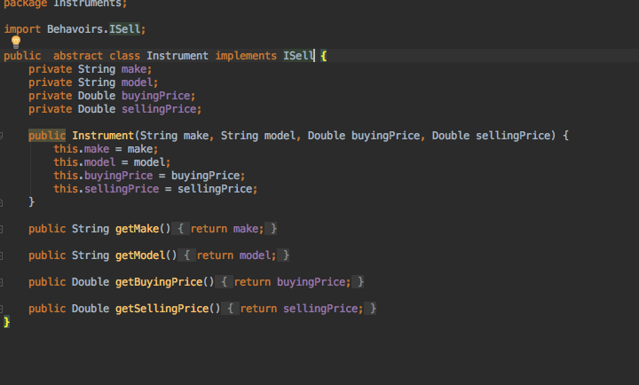

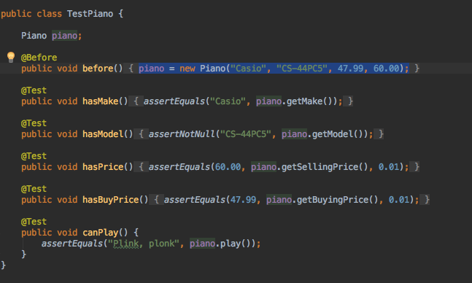

**Week 10**

| Unit | Ref | Evidence |  |
| --- | --- | --- | --- |
| P | P.11 | Take a screenshot of one of your projects where you have worked alone and attach the Github link. | |

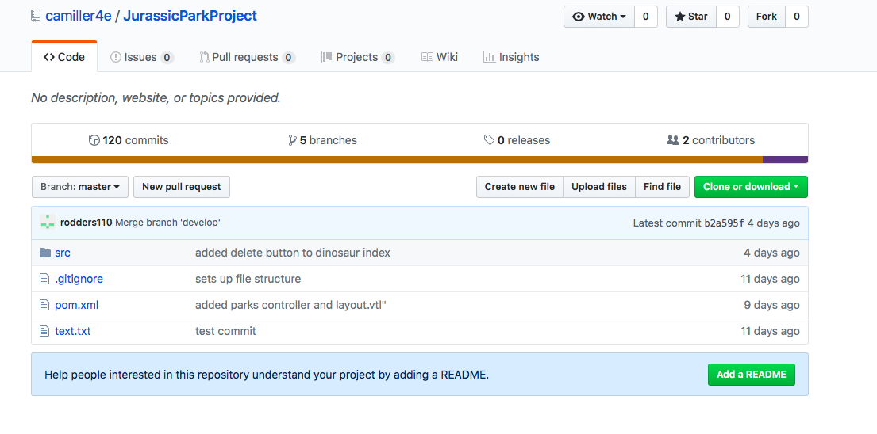

**https://github.com/camiller4e/JurassicParkProject**

| Unit | Ref | Evidence |  |
| --- | --- | --- | --- |
| P | P.12 | Take screenshots or photos of your planning and the different stages of development to show changes. | |

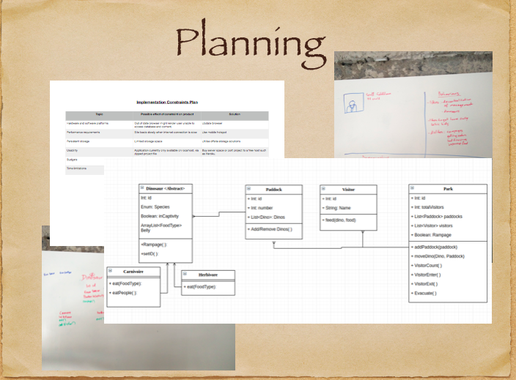

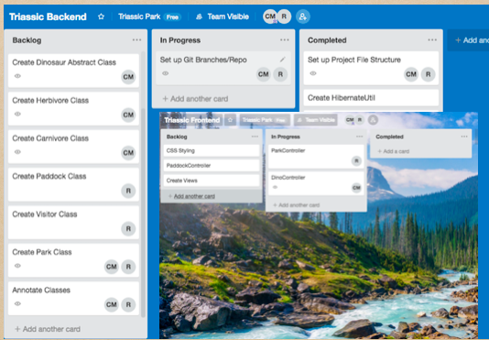

| Unit | Ref | Evidence |  |
| --- | --- | --- | --- |
| P | P.9 | Select two algorithms you have written (NOT the group project). Take a screenshot of each and write a short statement on why you have chosen to use those algorithms. | |

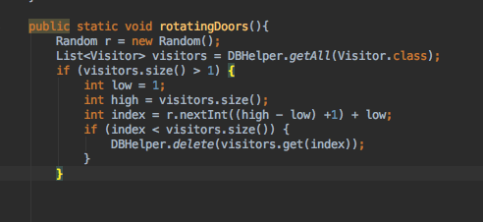

**This Algorithm selects a paddock object at Random to remove a visitor object, the create the illusion of visitors leaving the park in the project.**

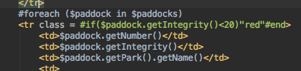

**This Algorithm generated the table information from the database and also has a conditional statement to alter the class tag of the table. Which effects the CSS.**

**Week 12**

| Unit | Ref | Evidence |  |
| --- | --- | --- | --- |
| P | P.16 | Show an API being used within your program. Take a screenshot of:  * The code that uses or implements the API  * The API being used by the program whilst running | |

**Paste Screenshot here**

**Description here**

**Week 15**

| Unit | Ref | Evidence |  |
| --- | --- | --- | --- |
| P | P.1 | Take a screenshot of the contributor’s page on Github from your group project to show the team you worked with. | |

**Paste Screenshot here**

**Description here**

| Unit | Ref | Evidence |  |
| --- | --- | --- | --- |
| P | P.2 | Take a screenshot of the project brief from your group project. | |

**Paste Screenshot here**

**Description here**

| Unit | Ref | Evidence |  |
| --- | --- | --- | --- |
| P | P.3 | Provide a screenshot of the planning you completed during your group project, e.g. Trello MOSCOW board. | |

**Paste Screenshot here**

**Description here**

| Unit | Ref | Evidence |  |
| --- | --- | --- | --- |
| P | P.4 | Write an acceptance criteria and test plan. | |

**Paste Screenshot here**

**Description here**

| Unit | Ref | Evidence |  |
| --- | --- | --- | --- |
| P | P.7 | Produce two system interaction diagrams (sequence and/or collaboration diagrams). | |

**Paste Screenshot here**

**Description here**

| Unit | Ref | Evidence |  |
| --- | --- | --- | --- |
| P | P.8 | Produce two object diagrams. | |

**Paste Screenshot here**

**Description here**

| Unit | Ref | Evidence |  |
| --- | --- | --- | --- |
| P | P.17 | Produce a bug tracking report | |

**Paste Screenshot here**

**Description here**